[](http://www.google.co.jp/imgres?start=187&hl=ja&sa=X&tbo=d&rlz=1T4GGLL_jaJP375JP376&biw=1071&bih=556&tbm=isch&tbnid=n0uhnfvkYgamNM:&imgrefurl=http://www.seiwa-p.co.jp/shop/ote/illust_01.aspx&docid=OED7V-yj6CvGnM&imgurl=http://www.seiwa-p.co.jp/images/ote_img/sozai_images/01_sakura_02.jpg&w=315&h=400&ei=K_T_UJaVOYaPlQXHt4CwBw&zoom=1&iact=hc&vpx=771&vpy=194&dur=478&hovh=253&hovw=199&tx=84&ty=172&sig=105717142852406232515&page=9&tbnh=157&tbnw=124&ndsp=26&ved=1t:429,r:98,s:100,i:298)





[](http://www.google.co.jp/imgres?hl=ja&sa=X&tbo=d&rlz=1T4GGLL_jaJP375JP376&biw=1071&bih=556&tbm=isch&tbnid=2vV0nWK1ph9rwM:&imgrefurl=http://sozaishu.seesaa.net/tag/%8D%F7&docid=c0MYwv8BWgTPhM&imgurl=http://sozaishu.up.seesaa.net/image/02520BAF9A1CAB2CFC4C5BAF9A1CBA1BFA5B5A5AFA5E9A1CAA5ABA5EFA5C5A5B5A5AFA5E9A1CBA1BFCherry20blossoms.gif&w=1000&h=800&ei=je7_ULS-HsSRkwWF4oGYAQ&zoom=1&iact=hc&vpx=201&vpy=51&dur=955&hovh=201&hovw=251&tx=135&ty=105&sig=105717142852406232515&page=2&tbnh=157&tbnw=196&start=18&ndsp=23&ved=1t:429,r:25,s:0,i:164)

[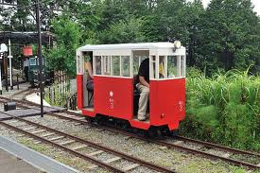](http://www.google.co.jp/imgres?start=238&hl=ja&sa=X&tbo=d&rlz=1T4GGLL_jaJP375JP376&biw=1071&bih=556&tbm=isch&tbnid=gtvG87lHcruO1M:&imgrefurl=http://kore.jp/okamo/2009c/sakurt200907.htm&docid=CNB0ed01X6D_PM&imgurl=http://kore.jp/okamo/2009c/sakurt200907-01.jpg&w=708&h=472&ei=cyUFUbzoFIyIkwXHnICQAw&zoom=1&ved=1t:3588,r:41,s:200,i:127&iact=rc&dur=2119&sig=105717142852406232515&page=19&tbnh=183&tbnw=273&ndsp=15&tx=166&ty=111)

[](http://www.google.co.jp/imgres?hl=ja&sa=X&tbo=d&rlz=1T4GGLL_jaJP375JP376&biw=1071&bih=556&tbm=isch&tbnid=Ow6rU9-EEZpfQM:&imgrefurl=http://cookie2001.exblog.jp/tags/%E3%83%9F%E3%82%B9%E3%83%89/&docid=eTGTJHSo9A1rsM&imgurl=http://pds2.exblog.jp/pds/1/201107/21/91/e0176691_17192771.jpg&w=600&h=513&ei=VPf_UKLxOcavkgXqnIDYDw&zoom=1&iact=hc&vpx=564&vpy=175&dur=2691&hovh=208&hovw=243&tx=114&ty=159&sig=105717142852406232515&page=1&tbnh=136&tbnw=156&start=0&ndsp=18&ved=1t:429,r:16,s:0,i:128)

[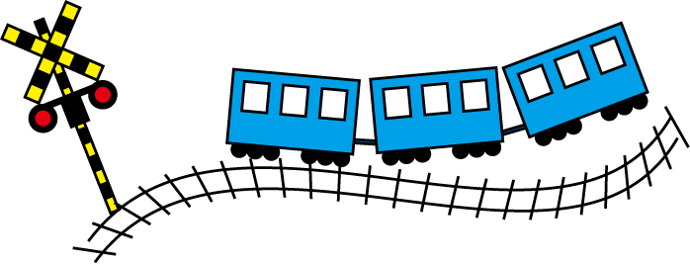](http://www.google.co.jp/url?sa=i&rct=j&q=&esrc=s&frm=1&source=images&cd=&cad=rja&docid=liM9XQc-PsGTgM&tbnid=lSc03VCMeNeIoM:&ved=0CAUQjRw&url=http://search.seesaa.jp/%E7%B7%9A%E8%B7%AF%20%E3%82%A4%E3%83%A9%E3%82%B9%E3%83%88/index.html&ei=BmQIUfL2HcnBkwWWhoDwBQ&bvm=bv.41642243,d.dGI&psig=AFQjCNHQIKVlAeAJaArXtIKDq-EWKEie5g&ust=1359590428883983)

[](http://www.google.co.jp/imgres?hl=ja&sa=X&tbo=d&rlz=1T4GGLL_jaJP375JP376&biw=1071&bih=556&tbm=isch&tbnid=2vV0nWK1ph9rwM:&imgrefurl=http://sozaishu.seesaa.net/tag/%8D%F7&docid=c0MYwv8BWgTPhM&imgurl=http://sozaishu.up.seesaa.net/image/02520BAF9A1CAB2CFC4C5BAF9A1CBA1BFA5B5A5AFA5E9A1CAA5ABA5EFA5C5A5B5A5AFA5E9A1CBA1BFCherry20blossoms.gif&w=1000&h=800&ei=je7_ULS-HsSRkwWF4oGYAQ&zoom=1&iact=hc&vpx=201&vpy=51&dur=955&hovh=201&hovw=251&tx=135&ty=105&sig=105717142852406232515&page=2&tbnh=157&tbnw=196&start=18&ndsp=23&ved=1t:429,r:25,s:0,i:164)

[](http://www.google.co.jp/imgres?hl=ja&sa=X&tbo=d&rlz=1T4GGLL_jaJP375JP376&biw=1071&bih=556&tbm=isch&tbnid=2vV0nWK1ph9rwM:&imgrefurl=http://sozaishu.seesaa.net/tag/%8D%F7&docid=c0MYwv8BWgTPhM&imgurl=http://sozaishu.up.seesaa.net/image/02520BAF9A1CAB2CFC4C5BAF9A1CBA1BFA5B5A5AFA5E9A1CAA5ABA5EFA5C5A5B5A5AFA5E9A1CBA1BFCherry20blossoms.gif&w=1000&h=800&ei=je7_ULS-HsSRkwWF4oGYAQ&zoom=1&iact=hc&vpx=201&vpy=51&dur=955&hovh=201&hovw=251&tx=135&ty=105&sig=105717142852406232515&page=2&tbnh=157&tbnw=196&start=18&ndsp=23&ved=1t:429,r:25,s:0,i:164)

